**Lucy and Yak Boards References**

**About Lucy and Yak**

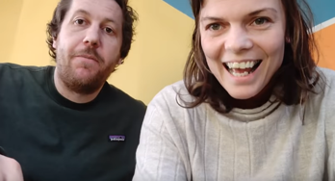 <https://www.youtube.com/watch?v=afkI8uNTWR4>

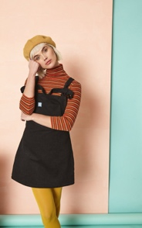 <https://lucyandyak.com/products/the-mini-pini-in-midnight-black>

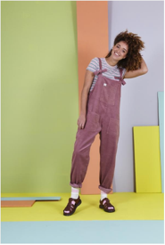 <https://www.coastandcountryinteriors.co.uk/all-products/lucy-and-yak-original-organic-cord-ash-pink-ladie-dungarees.html>

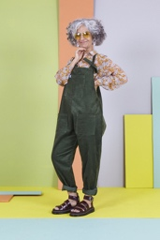 <https://www.the-pool.com/fashion/fashion-honestly/2018/31/Kate-Young-on-why-she-is-dressing-to-flatter-her-lifestyle-not-her-thighs>

Lucyandyak.com, *Our Story*, [online], Available at: <https://lucyandyak.com/pages/our-story>, Accessed on 14 March 2019

**Ethos and Values**

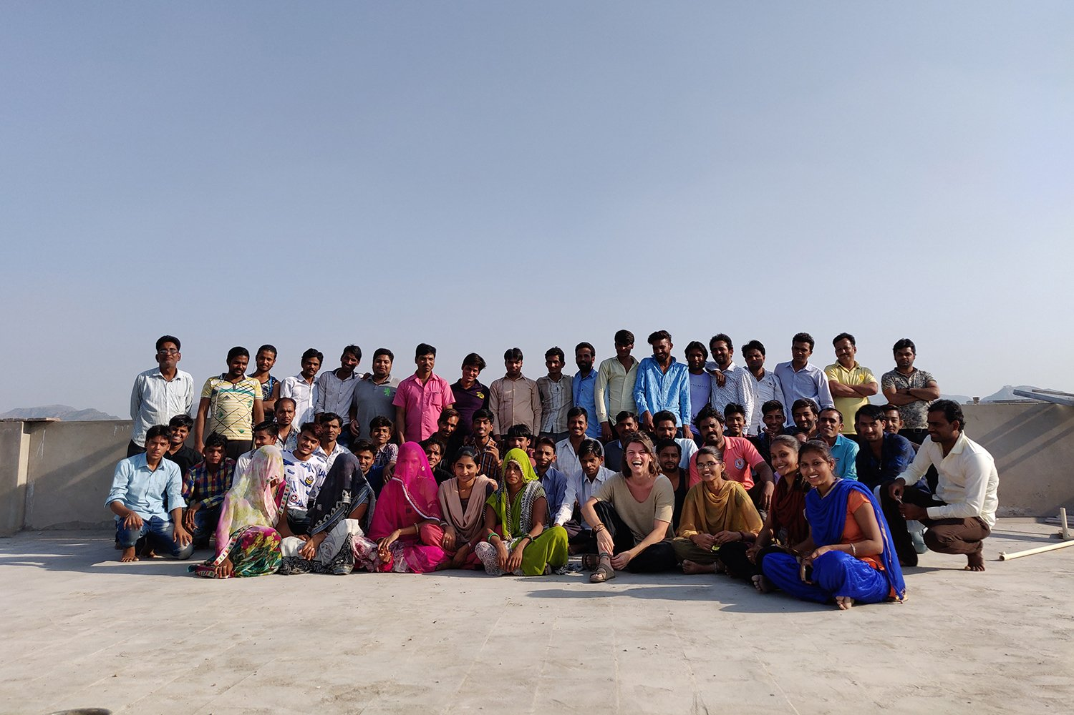 <https://lucyandyak.com/pages/our-ethics>

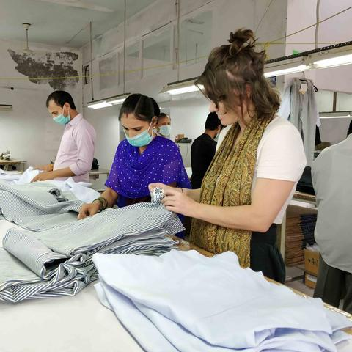https://lucyandyak.com/pages/partners-in-india

Lucyandyak.com. *Our Ethos,* (online), Available at: <https://lucyandyak.com/pages/our-ethics>, Accessed at 16 March 2019

Lucyandyak.com, *Our Values,* (online), Available at: <https://lucyandyak.com/pages/our-values>, Accessed at 16 March 2019

**Price Architecture**

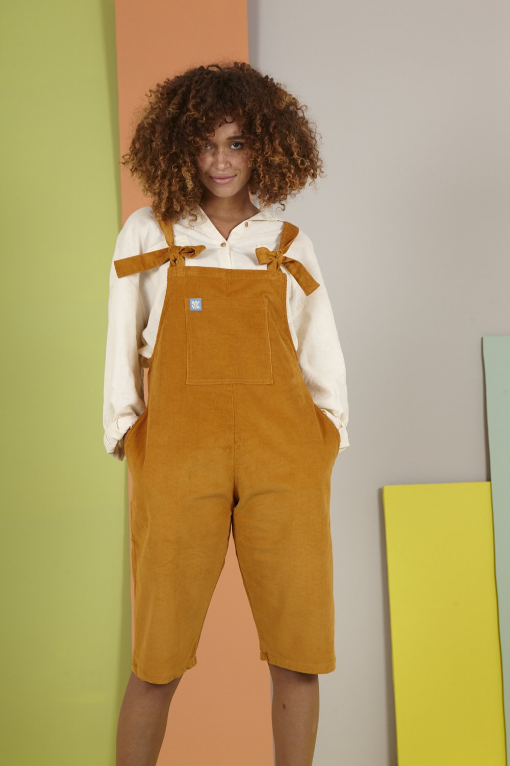 <https://lucyandyak.com/collections/the-original-mid-weight-corduroy-dungarees/products/original-shorts-mustard>

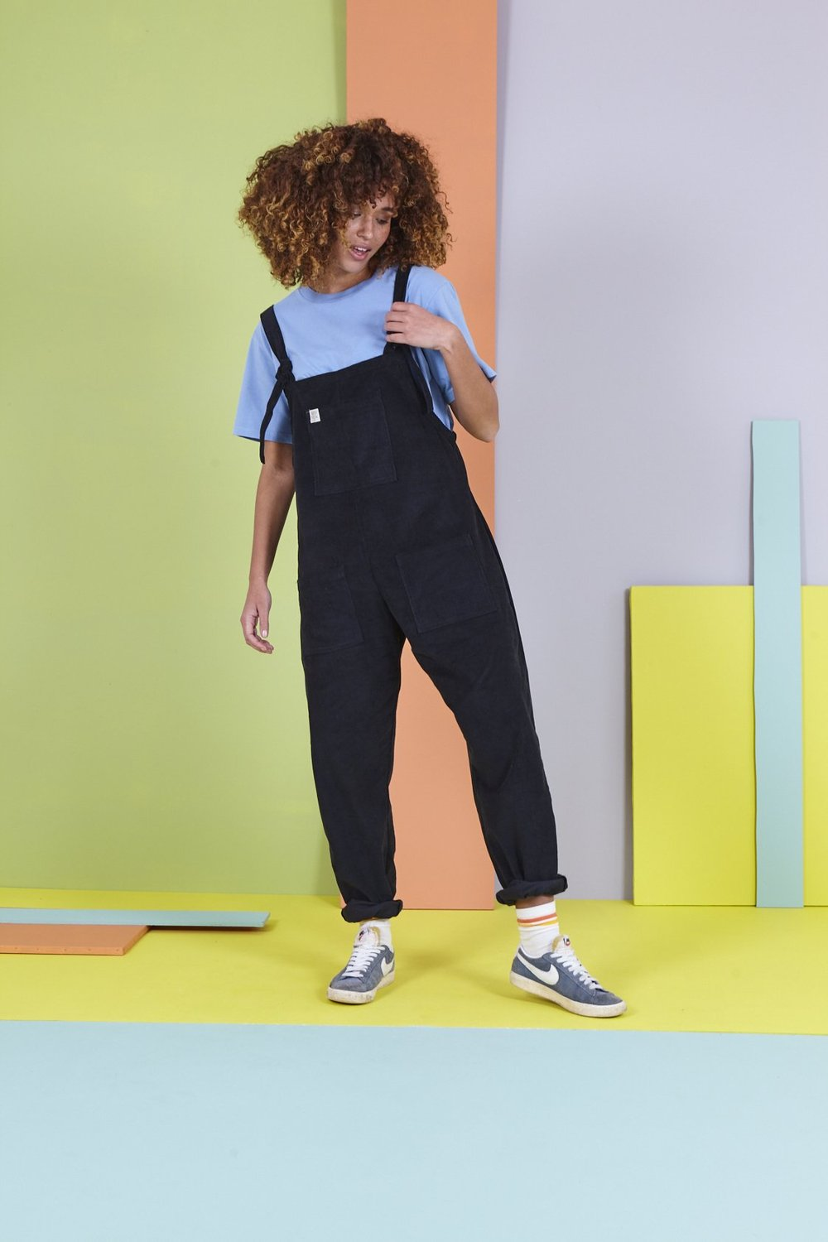https://lucyandyak.com/products/tall-the-organic-original-corduroy-dungarees-in-charcoal-black

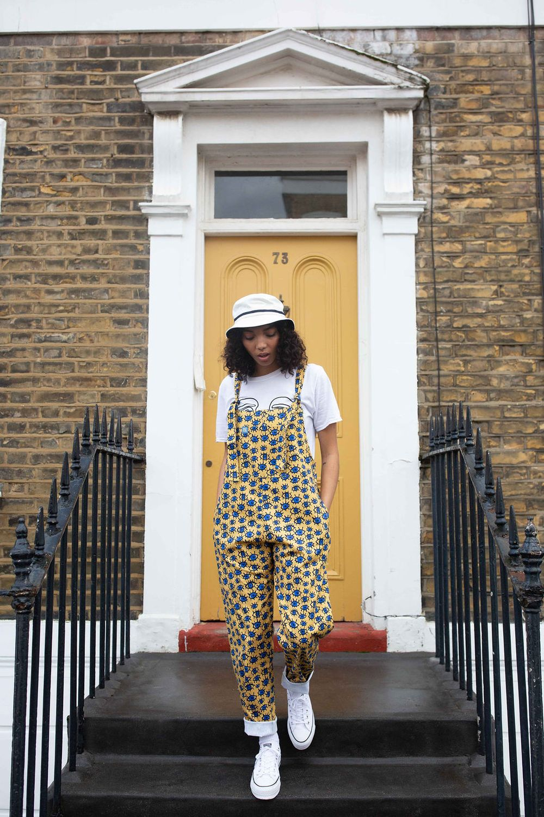 <https://lucyandyak.com/collections/limited-edition-mid-weight-cotton-dungarees/products/le-38-dungarees>

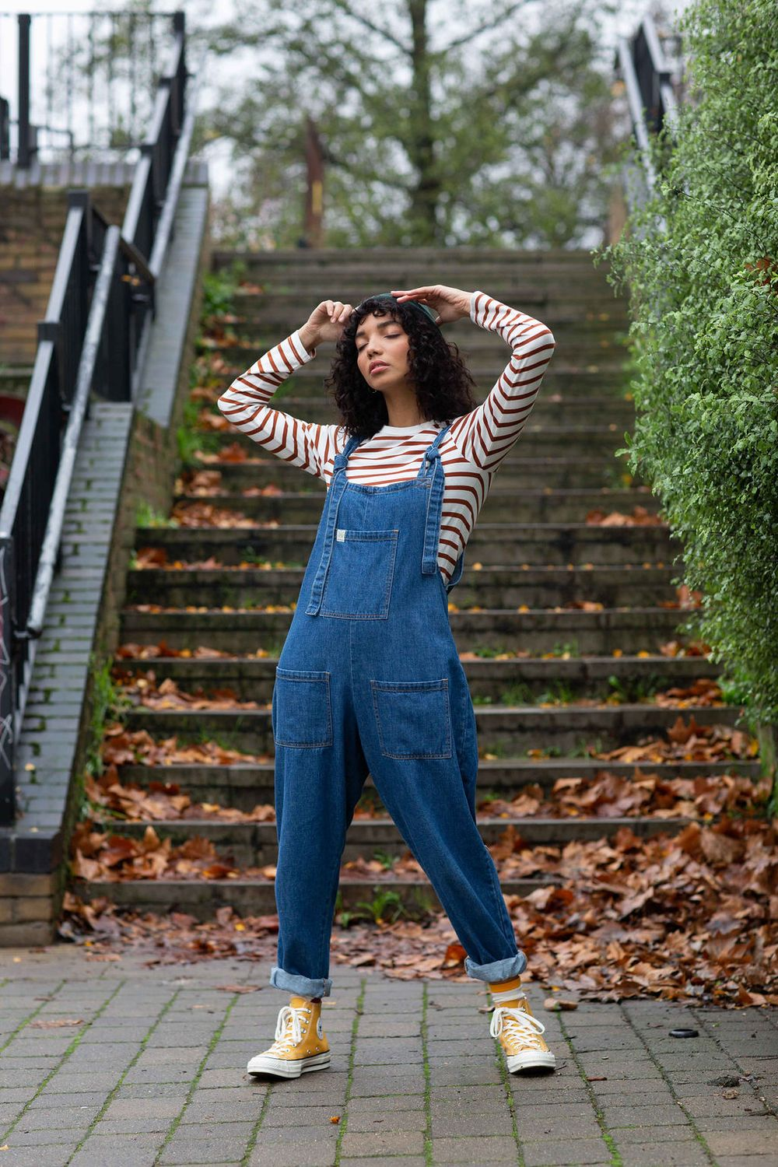 https://lucyandyak.com/collections/atlas/products/denim-dungarees

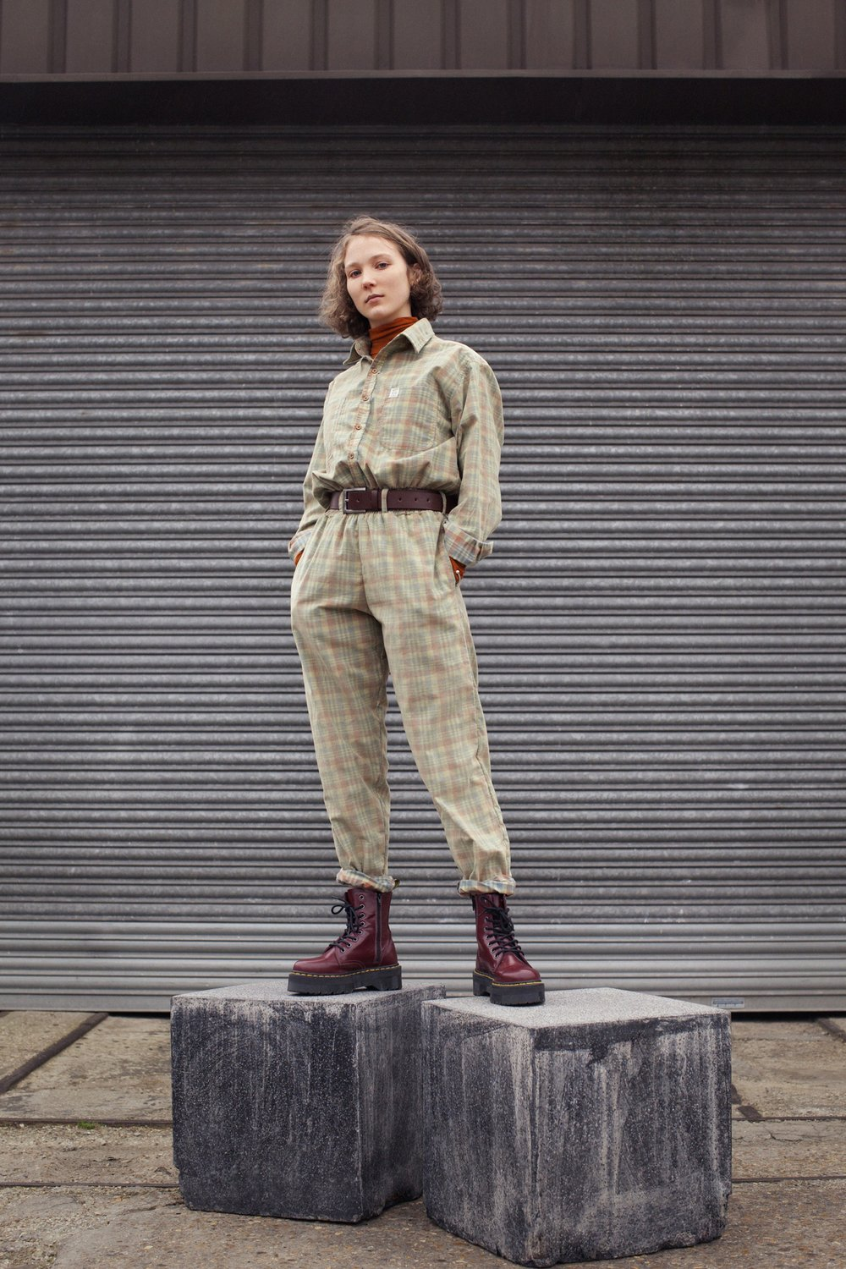<https://lucyandyak.com/collections/boilersuits/products/eddie-corduroy-boilersuit-in-earthy-checked>

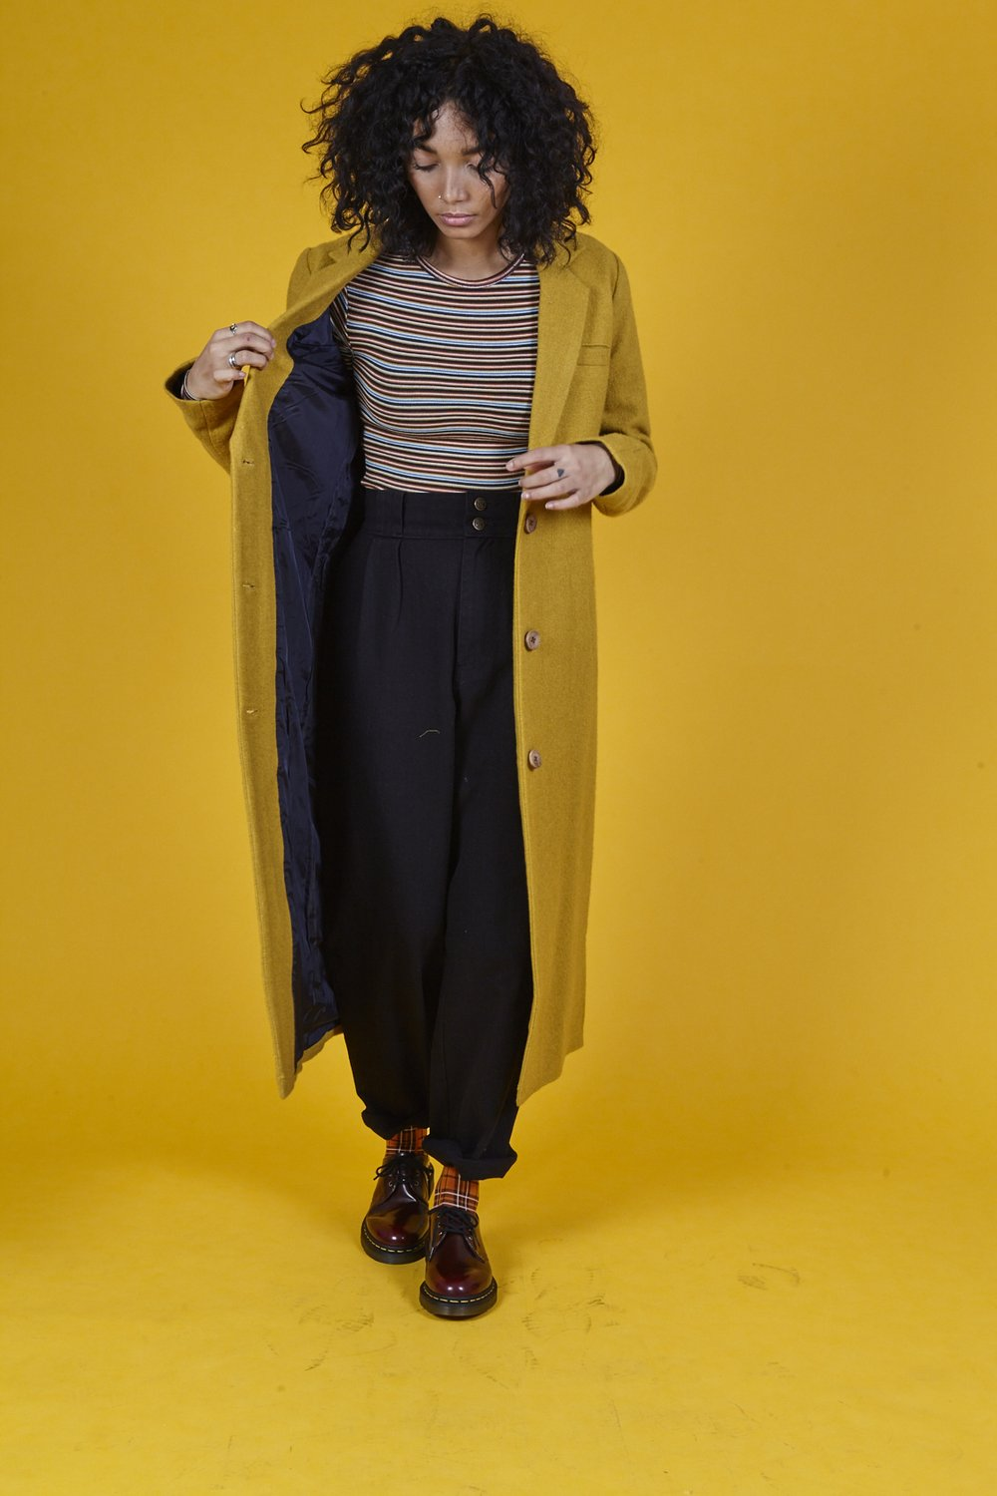 <https://lucyandyak.com/collections/outerwear/products/long-mustard-coat>

**Past Campaigns**

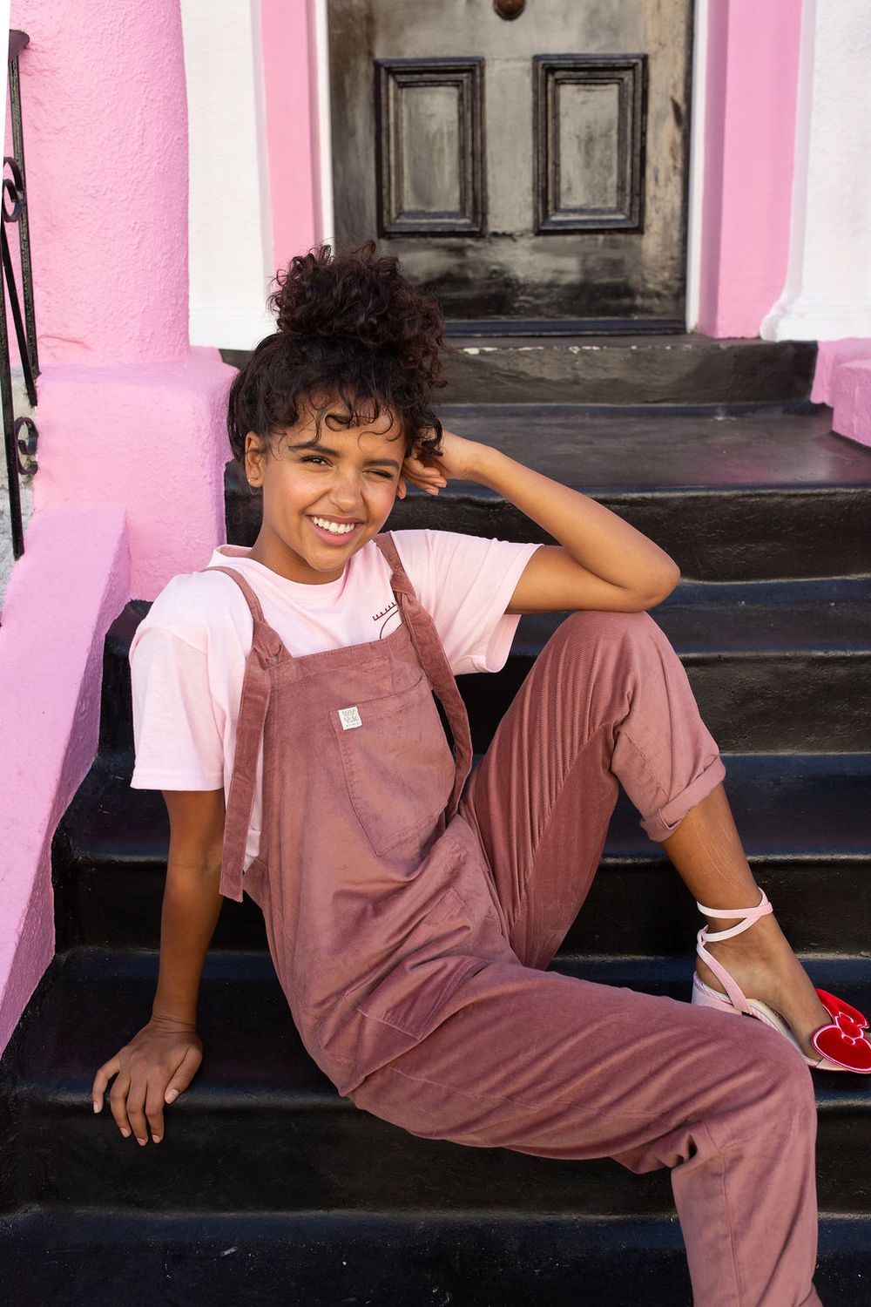 (x3 Photos) <https://lucyandyak.com/collections/best-sellers/products/organic-originals-ash-pink>

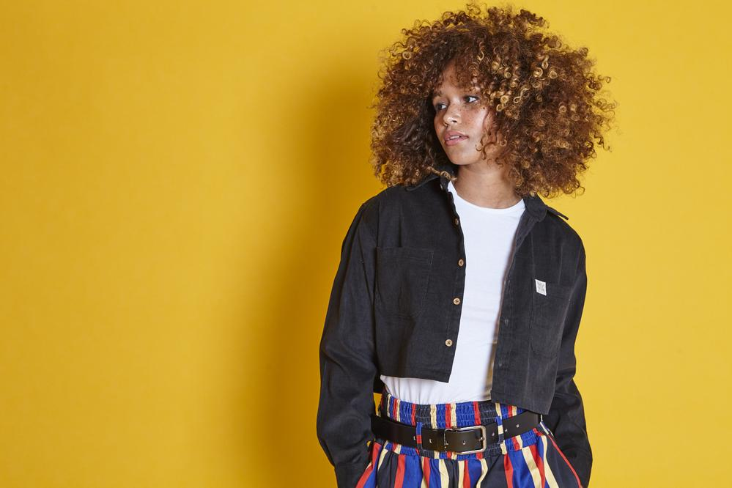 (x3 photos) <https://lucyandyak.com/products/cropped-shirt-black?variant=8179709476967>

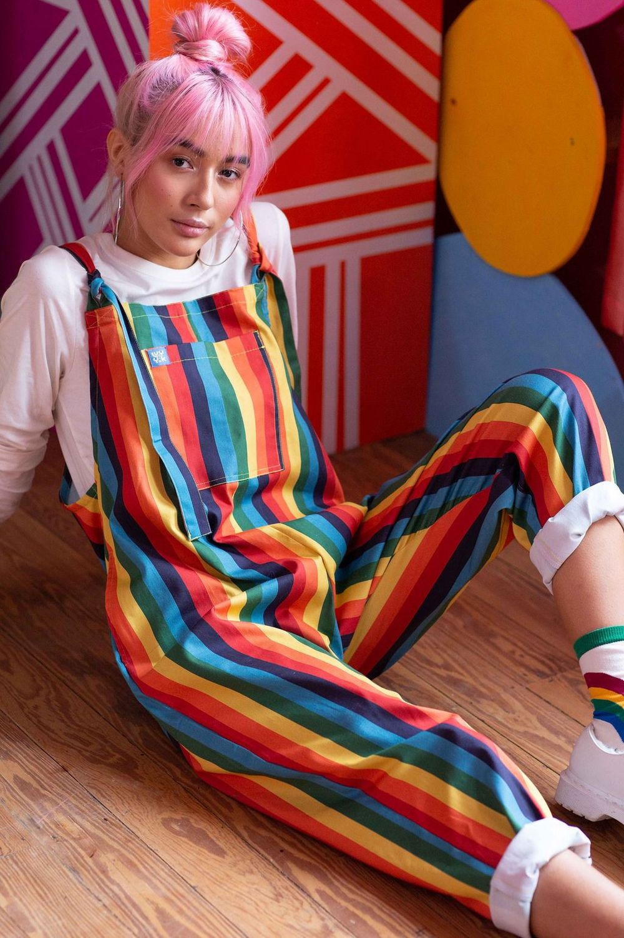 (x3 photos) https://lucyandyak.com/products/stp-yd-004-limited-edition-rainbow-stripe-organic-yarn-dye-dungarees

**Future Costumer Profile**

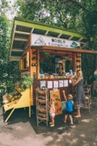 https://www.barefootblonde.com/2017/05/looking-like-ireland/

 <https://thehearnes.com/blog/moab-utah-keith-brianna-madia>

 <https://www.hongkiat.com/blog/father-daughter-photography/>

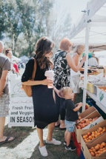 <https://www.hellofashionblog.com/2016/07/wheeler-farm-farmers-market.html>

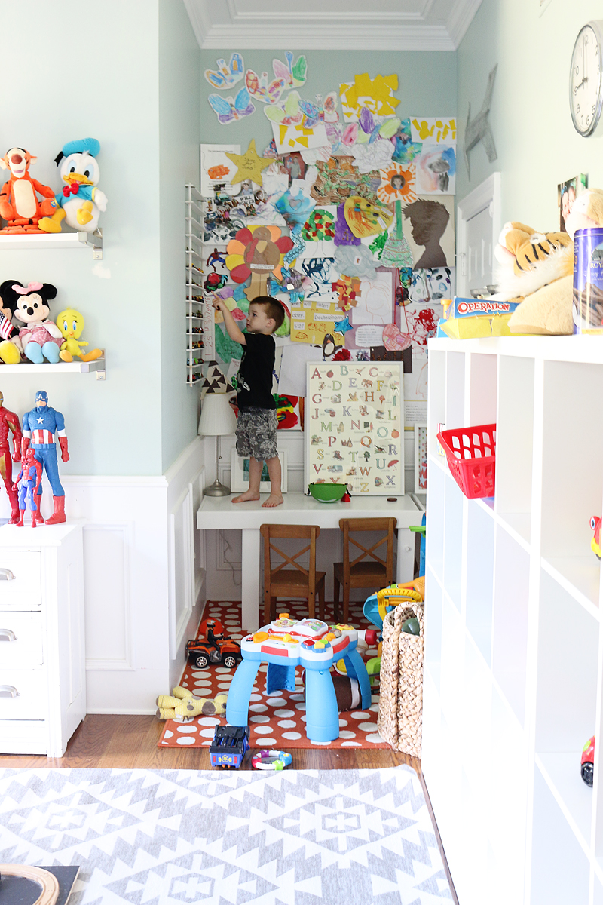 <https://www.bowerpowerblog.com/our-messy-wonderful-house/>

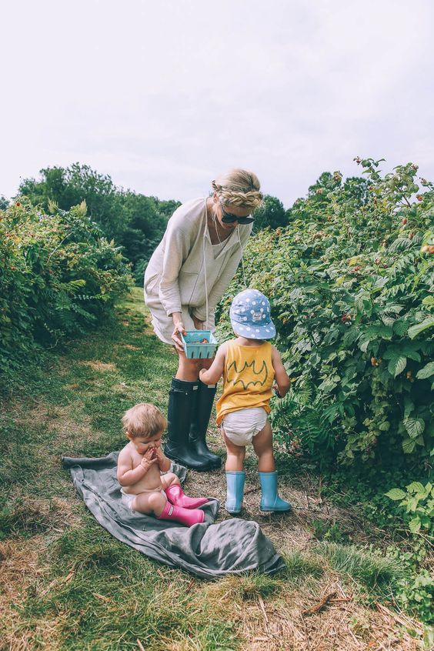 <https://www.barefootblonde.com/2016/07/berry-picking-pie-making/>