**Proposals References**

**Positioning**

Fashionrevolution.org, *Brands, Wholesalers. Retailers and Distributors*, (online), Available at:<https://www.fashionrevolution.org/about/get-involved/retailer/brands/>, Accessed 20 April 2019

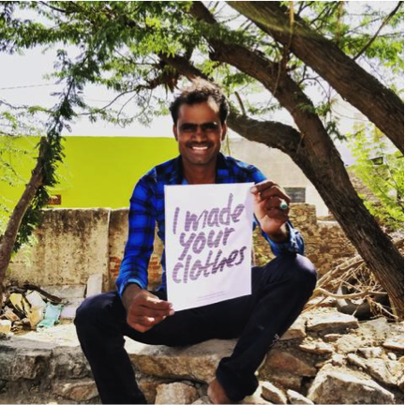 <https://lucyandyak.com/pages/partners-in-india>

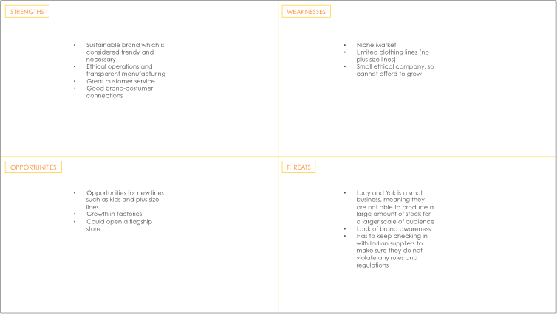 Own

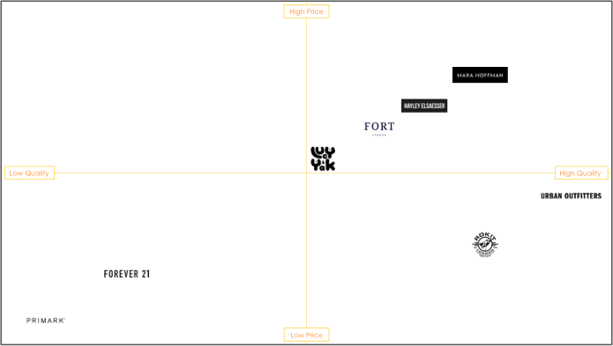 Own

 <https://www.livforinteriors.co.uk/blog/2019/asos-launches-new-homeware-collection>

**Environment**

Lucy and Yak, 2018, *Meet the L&Y Team,* (YouTube video), Available at: <https://www.youtube.com/watch?v=x5uehzJSDs4&t=3s>, Accessed March 10 2019

Lucyandyak.com, *Partners in India,* (online), Available at: <https://lucyandyak.com/pages/partners-in-india>, Accessed 10 March 2019

Lucyandyak.com, *We Love Art,* (online), Available at: <https://lucyandyak.com/pages/weloveart>, Accessed 10 March 2019

Lucyandyak.com, *Our Story,* (online), Available at: <https://lucyandyak.com/pages/our-story>, Accessed 10 March 2019

 https://www.beautypackaging.com/contents/view_breaking-news/2018-04-12/glossier-opens-a-retail-store-in-la

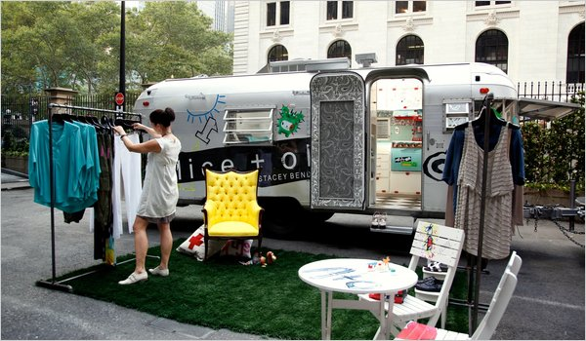<https://www.nytimes.com/2010/07/15/fashion/15AIRSTREAM.html>

**Sustainability**

thegoodtrade.com, *11 Ethical & Organic Lingerie Brands For The Modern Woman*, (online), Available at: <https://www.thegoodtrade.com/features/ethical-lingerie-brands>, Accessed on 9 March 2019

Wikipedia.com, Wikipedia contributors, *Zero Waste*, (online), Available at: <https://en.wikipedia.org/w/index.php?title=Zero_waste&oldid=881421244> Accessed 26 February 2019

Lucyandyak.com, *'Stevie' Oversized Polar Fleece in Orange & Teal*, (online), Available at: https://lucyandyak.com/collections/outerwear/products/orange-fleece, Accessed 26 February 2019

Parliament.uk Environmental Audit Committee, (2019), F*ixing fashion: clothing consumption and sustainability,* (online report), Available at: <https://publications.parliament.uk/pa/cm201719/cmselect/cmenvaud/1952/report-summary.html>, Accessed at 26 February 2019

Thedrum.com, J. McCarthy, 2018, *Unilever's sustainable brands are the fastest growing part of its business*, (online), Available at:<https://www.thedrum.com/news/2018/05/10/unilevers-sustainable-brands-are-the-fastest-growing-part-its-business>, Accessed 26 February 2019

 <https://www.thegoodtrade.com/features/ethical-lingerie-brands>

**Strategic Marketing**

Theguardian.com, 2015, D. Roberts and S. Siddiqui, *Gay marriage declared legal across the US in historic Supreme Court ruling,* (online), Available at: <https://www.theguardian.com/society/2015/jun/26/gay-marriage-legal-supreme-court>, Accessed 2 March 2019

Lucy and Yak, 2018, *What Went Wrong,* (YouTube video), Available at: <https://www.youtube.com/watch?v=E30O6dfK-OE>, Accessed 2 March 2019

 <https://www.csmonitor.com/Business/new-economy/2015/0110/Why-Tiffany-is-now-advertising-to-same-sex-couples>

<https://www.paperchase.com/en_gb/treat-me-info>

**Marketing Communications**

#### Neumarkets.com, Cornacchia, [online], *Why Do I Keep Seeing the Same Ads?,* Available at [https://neumarkets.com/how-remarketing-works/], Assessed 23 February 2019

#### Lucy and Yak, 2019, *Lucy & Yak| Instagram plus size response*, (YouTube video), Available at: <https://www.youtube.com/watch?v=afkI8uNTWR4>, Accessed 23 February 2019

Lucyandyak.com, *We Love Art,* (online), Available at: <https://lucyandyak.com/pages/weloveart>, Accessed 10 March 2019

#### Adhesion.co.nz, Waldegrave, [online], *What is Google Remarketing and How It Works*, Available at [https://www.adhesion.co.nz/blog/google-remarketing-how-it-works], Accessed 23 February 2019

#### Lucy and Yak, 2019, *The Creative Life of* Dungarees, (YouTube video), Available at: <https://www.youtube.com/playlist?list=PLS1kGna_7qvie9ew2OC8LWsG-q-13zbVB>, Accessed 23 February 2019

#### Apple.com, *Trained,* (online), Available at: <https://podcasts.apple.com/gb/podcast/trained/id1414073313>, Accessed 23 February 2019

# Jeffree Star, 2017, *BEST MATTE LIPSTICK ON EARTH?? Pat McGrath MatteTrance Review + Swatches*, (YouTube Video), Available at: <https://www.youtube.com/watch?v=9t8jiXpYcE0>, Accessed 23 February 2019

#### <https://podcasts.apple.com/gb/podcast/trained/id1414073313>

#### (x2 Photos) <https://www.youtube.com/watch?v=9t8jiXpYcE0>

#### Brand Value

Lucyandyak.com, *Our Values*, (online), Available at: <https://lucyandyak.com/pages/our-values>, Accessed 29 April 2019

Lucyandyak.com, *What is fair pay to us*, (online), Available at: <https://lucyandyak.com/pages/what-is-fair-pay-to-us>, Accessed 29 April 2019

Numbeo.com, *Cost of living in India*, (online), Available at: <https://www.numbeo.com/cost-of-living/country_result.jsp?country=India>, Accessed 29 April 2019

Lucyandyak.com, *Organic Originals Black*, (online), Available at: <https://lucyandyak.com/products/organic-originals-black>, Accessed 29 April 2019

Lucyandyak.com, *The Living Wage*, (online), Available at: <https://lucyandyak.com/pages/the-living-wage>, Accessed 29 April 2019

Torontoenvironment.org, *Benefits of Zero Waste*, (onlie), Available at: <https://www.torontoenvironment.org/zerowaste_benefits>, Accessed 29 April 2019

Lucyandyak.com, Lucy and Chris, 2018, *Why India*, (online), Available at: <https://lucyandyak.com/blogs/news/why-india>, Accessed 29 April 2019

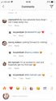<https://www.instagram.com/p/Bw1kv4agSj4/>

#### INNOVATION

Lucyandyak.com, 2018, Lucy and Yak, *Focus on Fabric: Recycled Polester,* (online), Available at:<https://lucyandyak.com/blogs/news/focus-on-fabric-recycled-polyester>, Accessed 2 May 2019

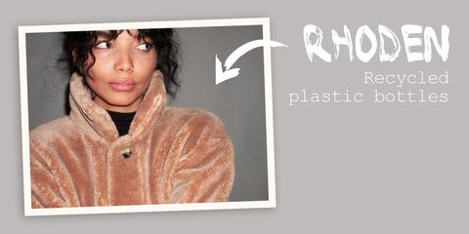<https://lucyandyak.com/blogs/news/focus-on-fabric-recycled-polyester>