EVALUATION IMAGE REFERENCES

 Own

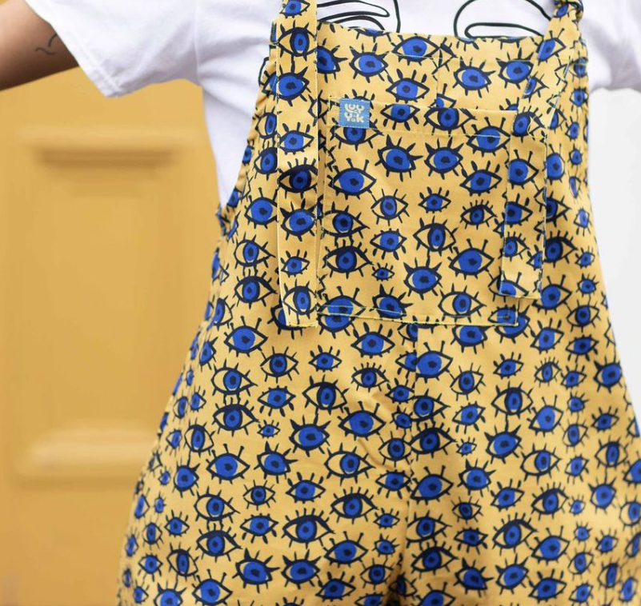 https://lucyandyak.com/products/le-38-dungarees

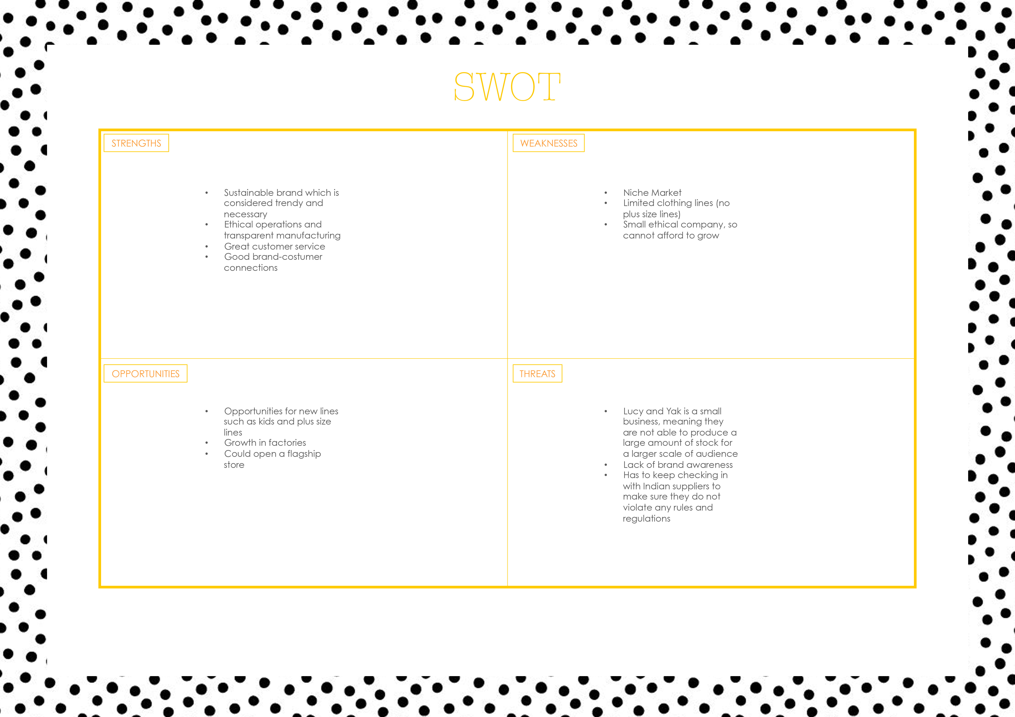 Own

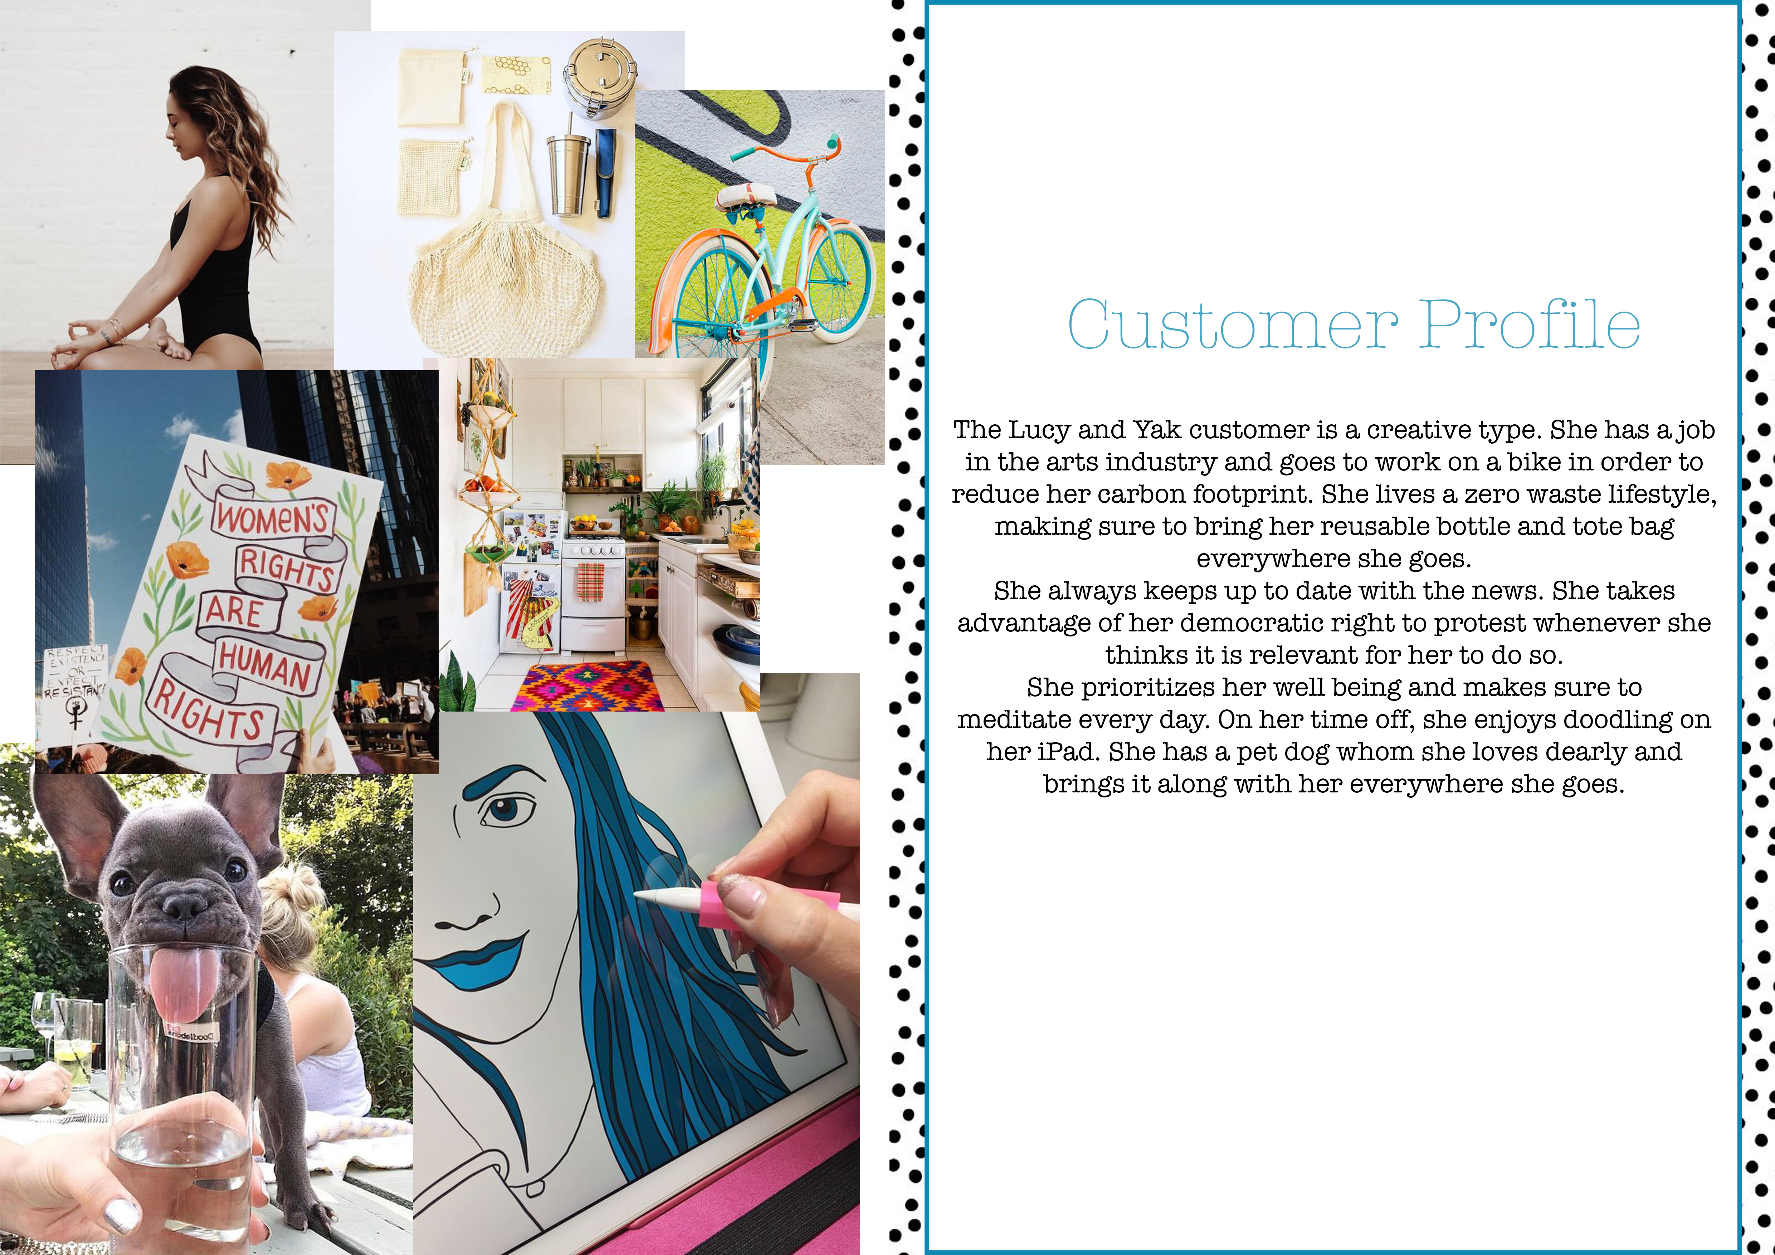 Own

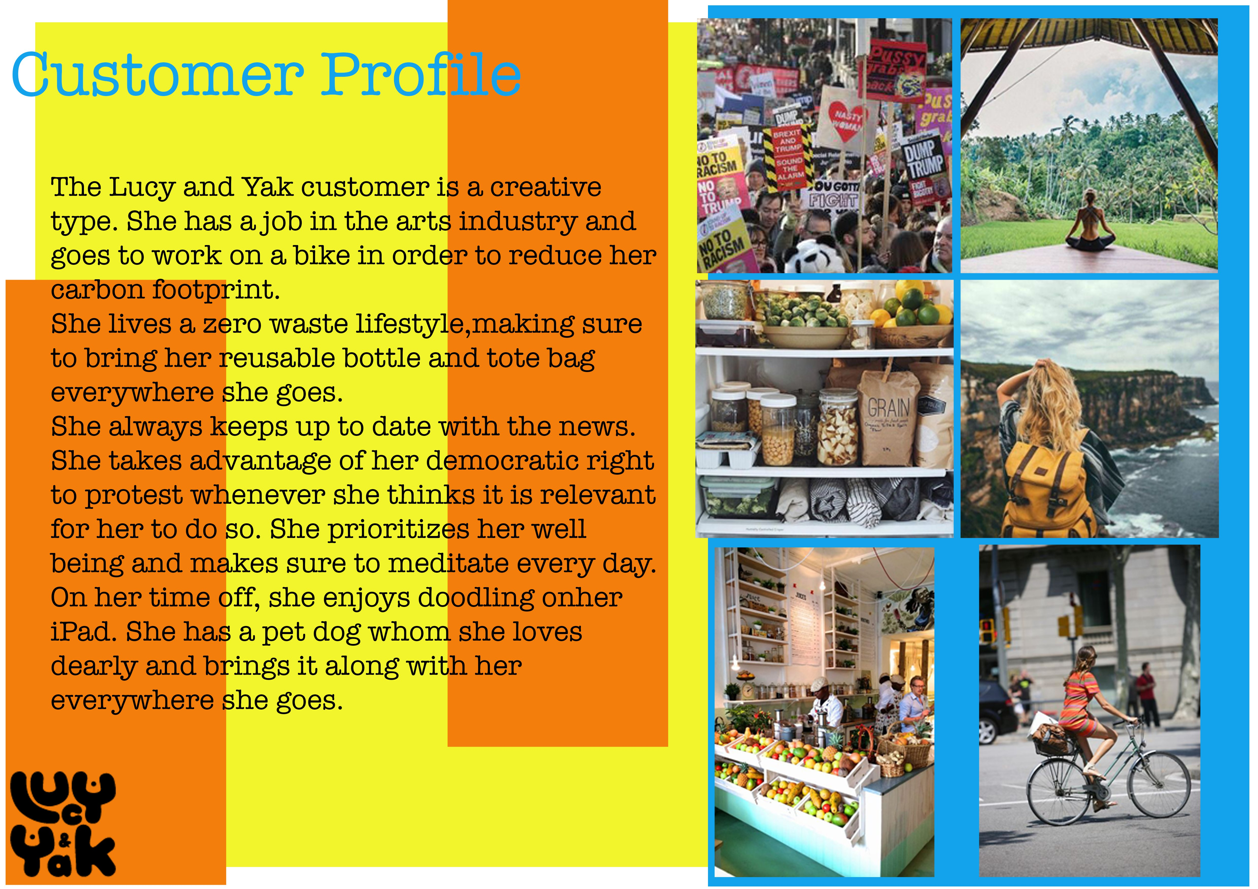 Own

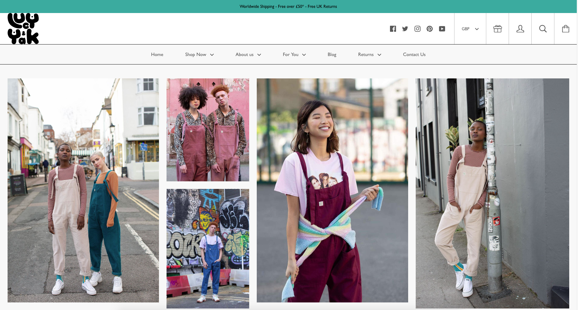www.lucyandyak.com

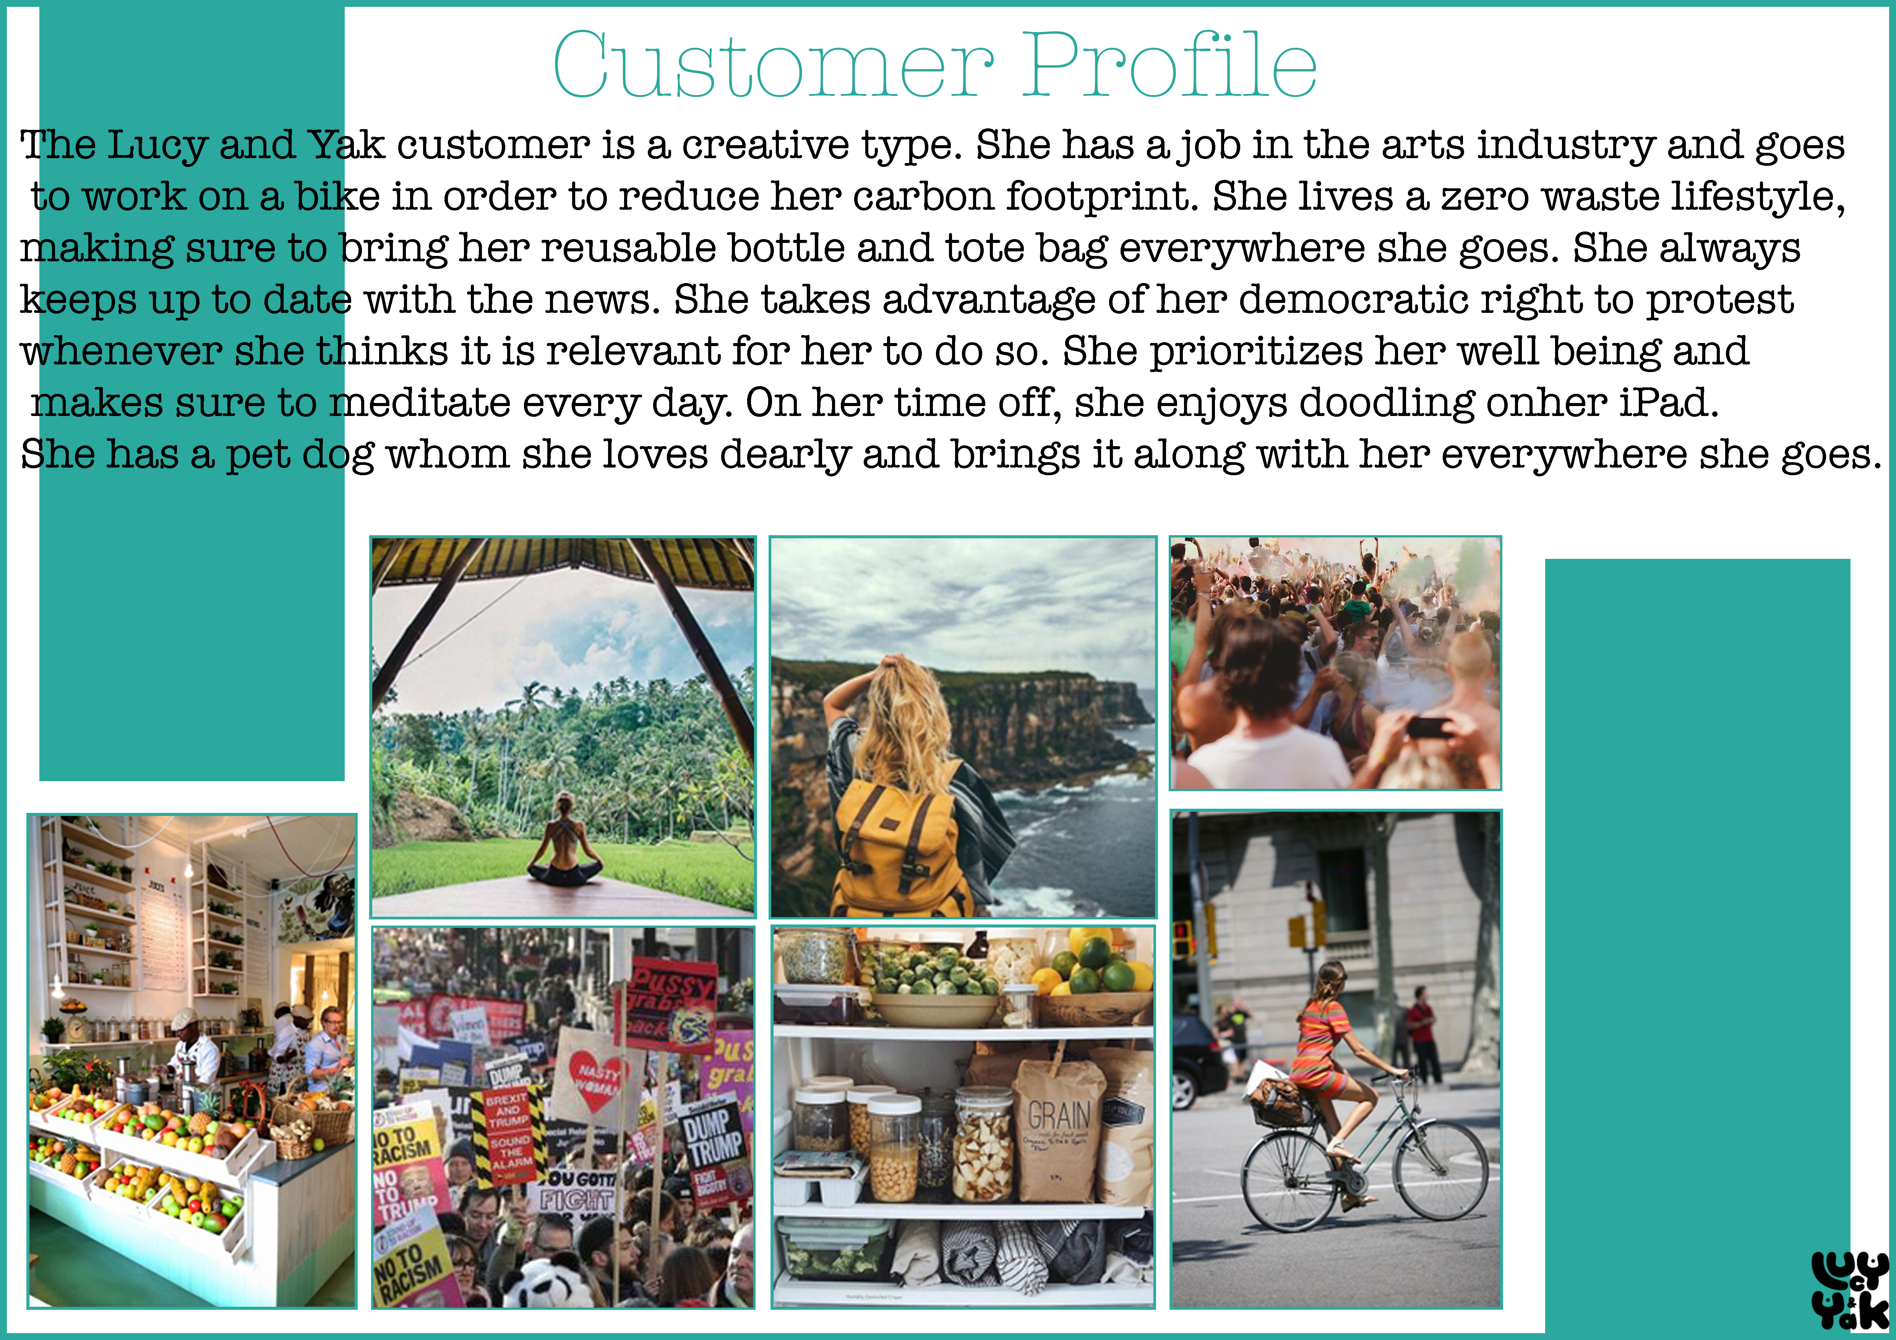Own

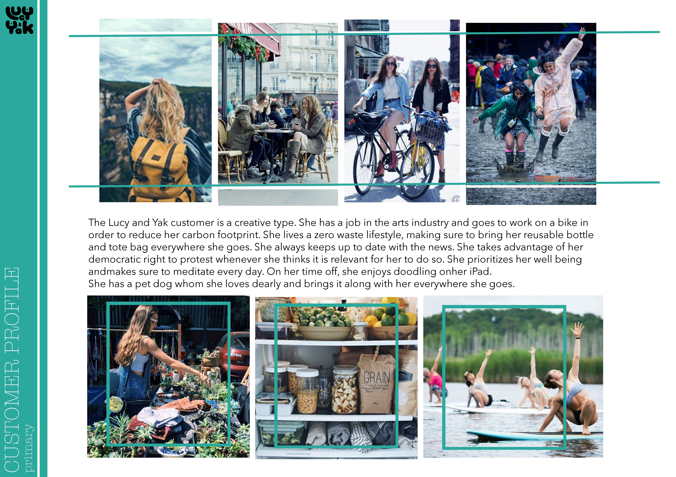 Own

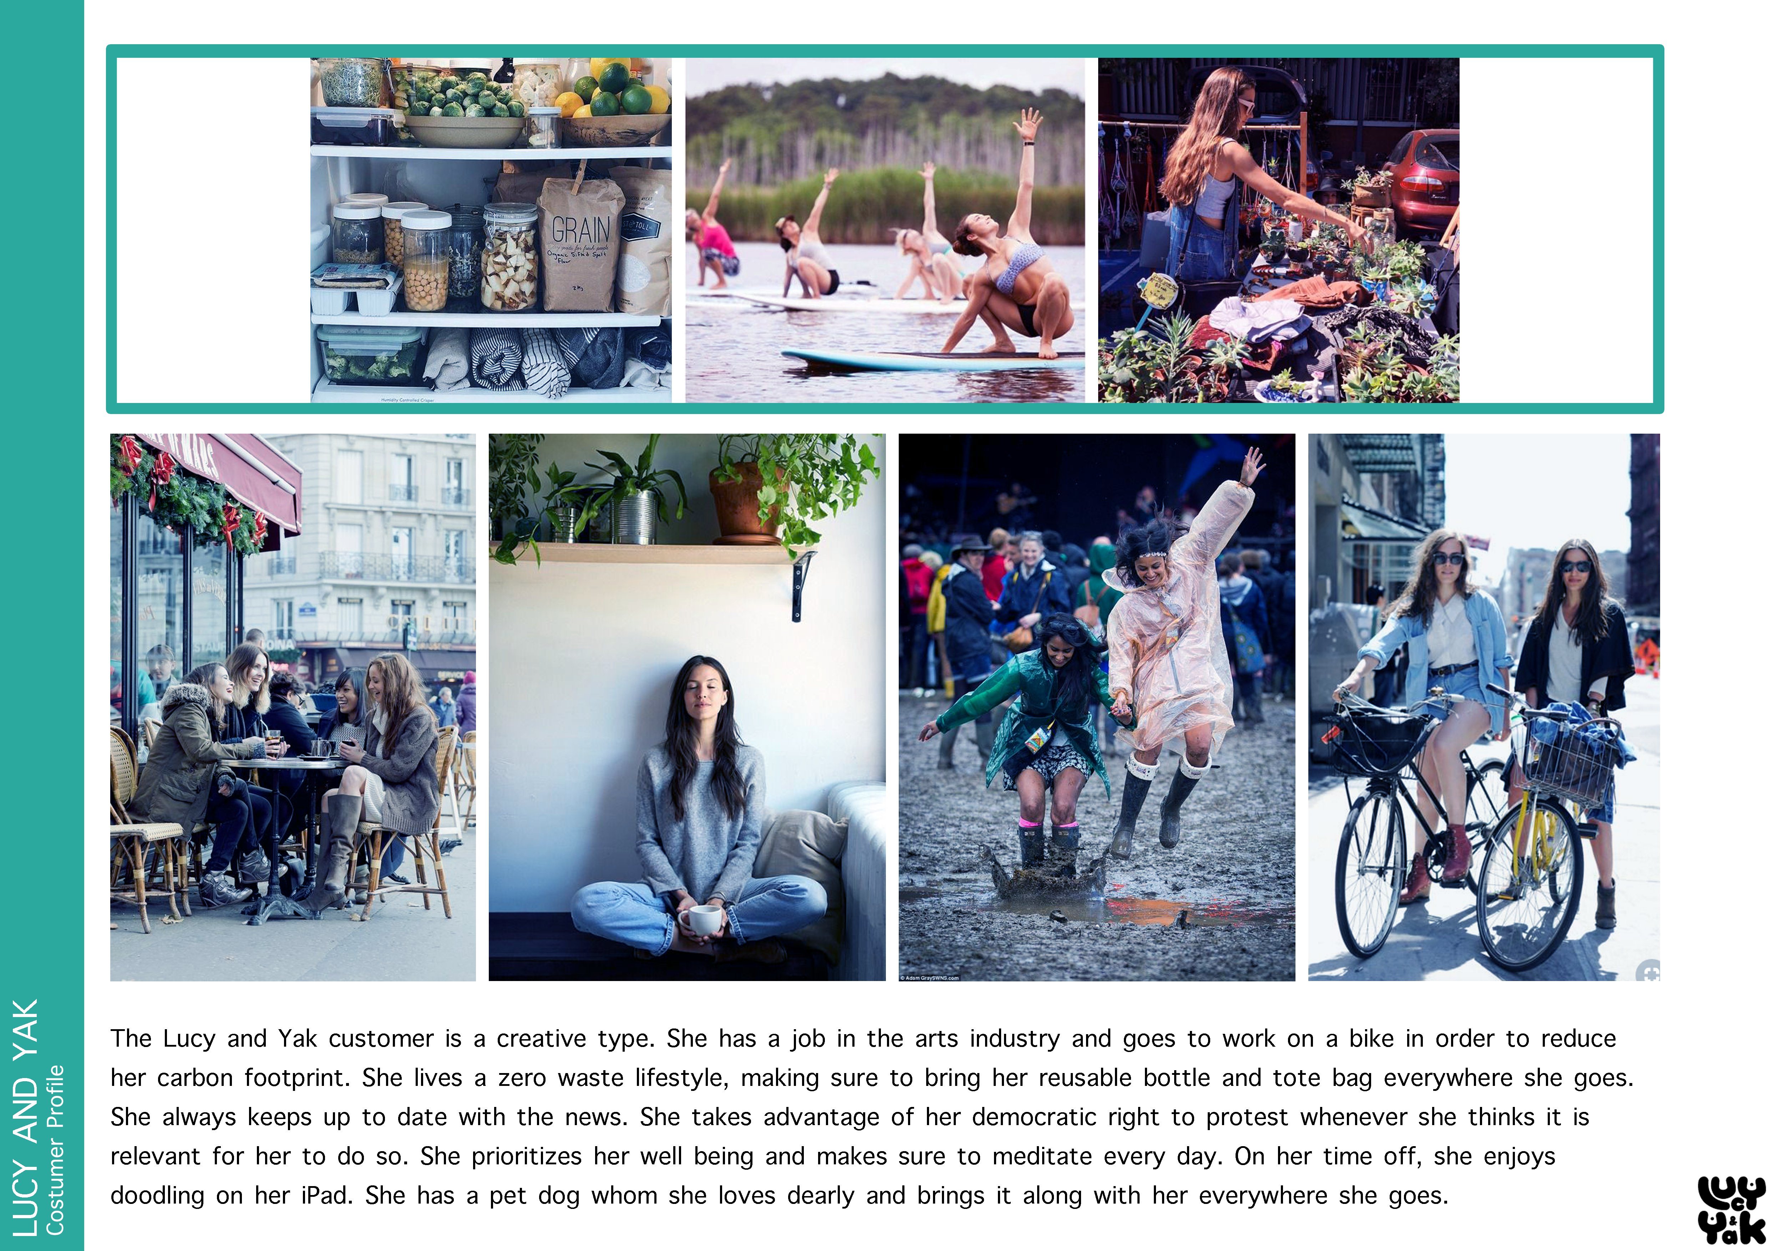 Own

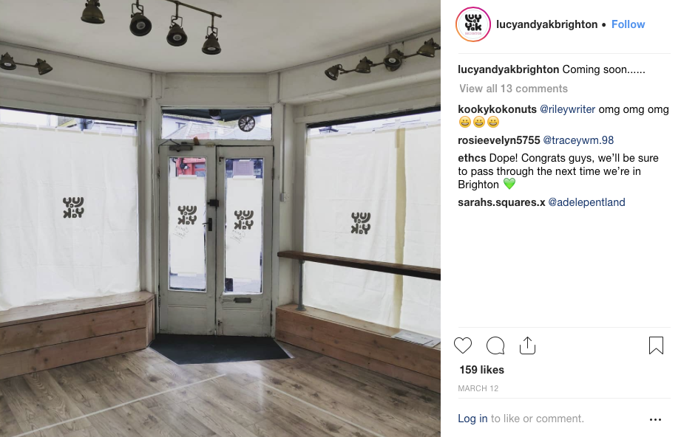https://www.instagram.com/lucyandyakbrighton/

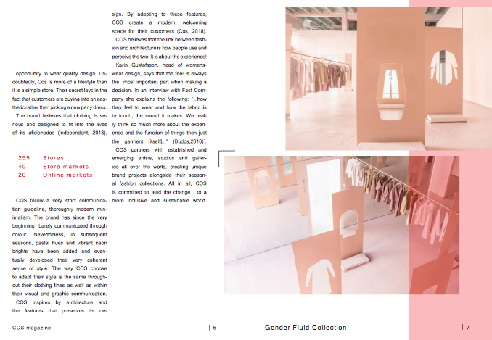https://issuu.com/hannalos/docs/the_gender_fluid_collection_-_cos

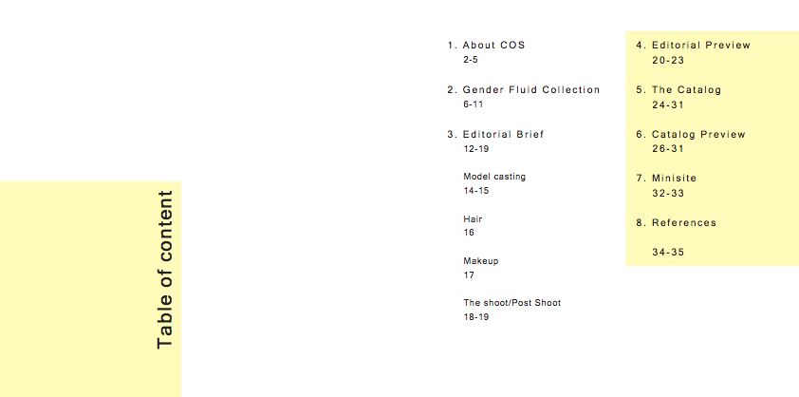https://issuu.com/hannalos/docs/the_gender_fluid_collection_-_cos

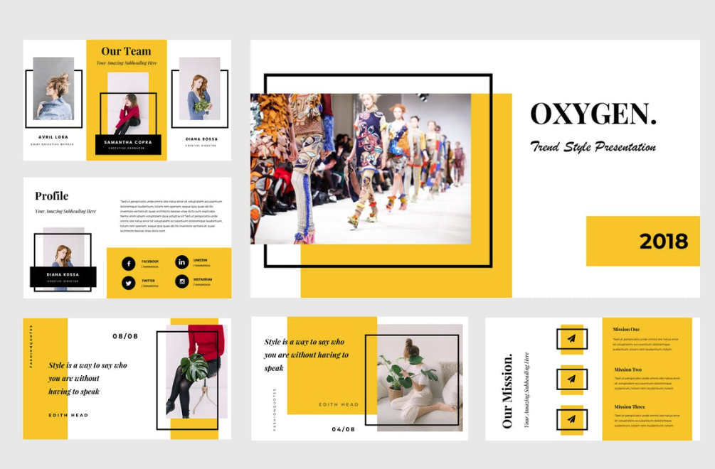https://elements.envato.com/oxygen-google-slides-presentation-JCSWZU?_ga=2.244563020.871335.1557153764-37660049.1557153764

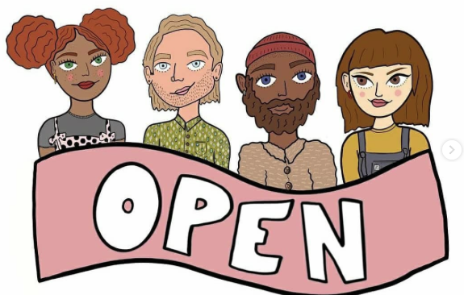https://www.instagram.com/lucyandyakbrighton/

https://www.instagram.com/lucyandyakbrighton/

