Presentation References

https://lucyandyak.com/collections/the-original-mid-weight-corduroy-dungarees/products/organic-originals-navy-blue

 https://www.youtube.com/watch?v=afkI8uNTWR4

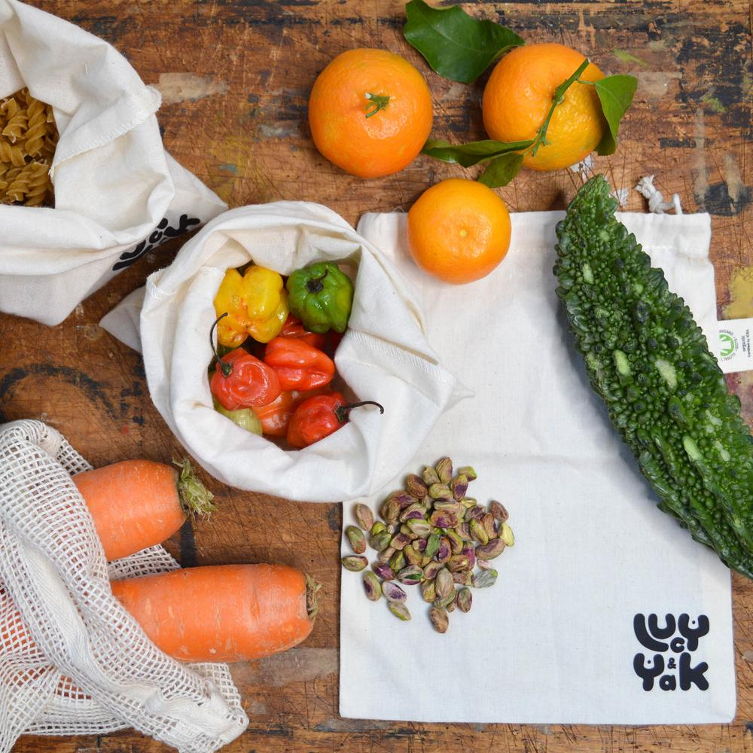 https://lucyandyak.com/collections/zero-waste-living/products/organic-cotton-muslin-produce-bag-pack-of-3

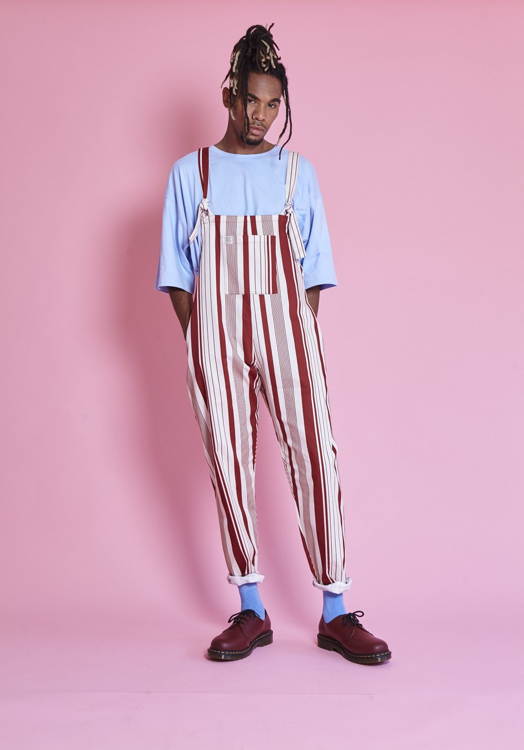 https://lucyandyak.com/collections/menswear-lucy-and-yak-dungarees/products/peppermint-limited-edition-red-and-cream-stripe-dungarees

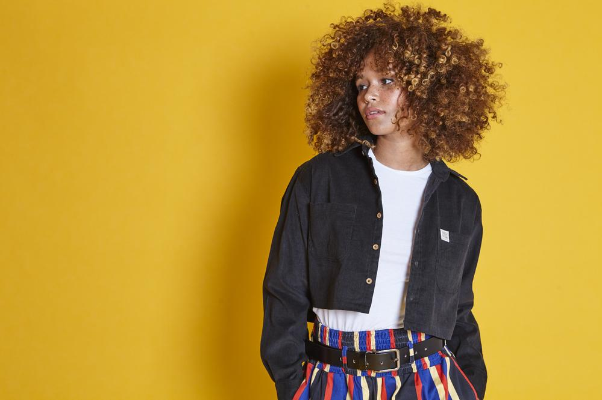 https://lucyandyak.com/products/cropped-shirt-black?variant=12279603101799

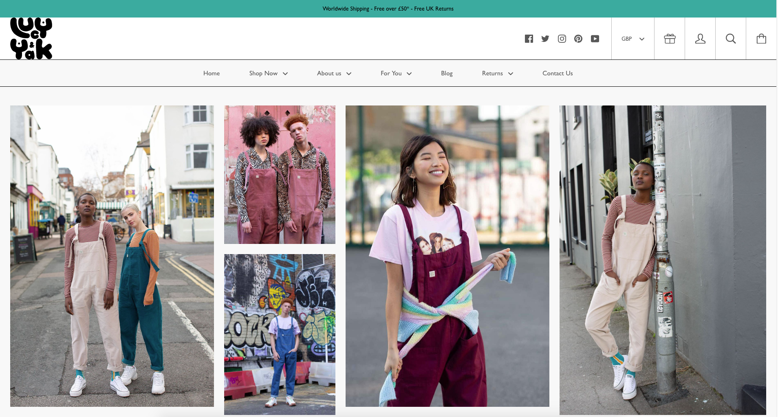 www.lucyandyak.com

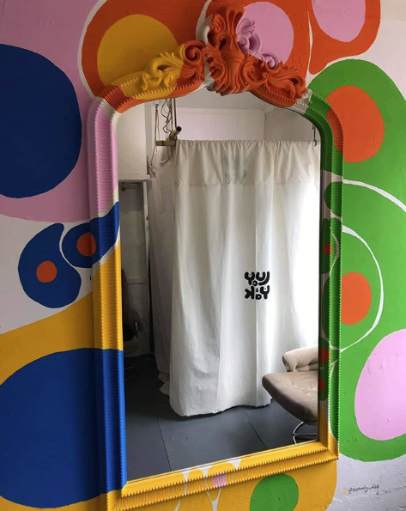https://www.instagram.com/lucyandyakbrighton/

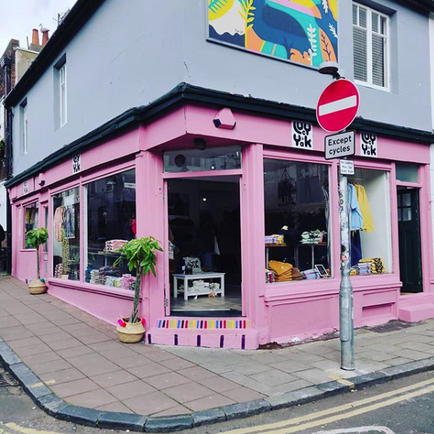https://www.instagram.com/lucyandyakbrighton/

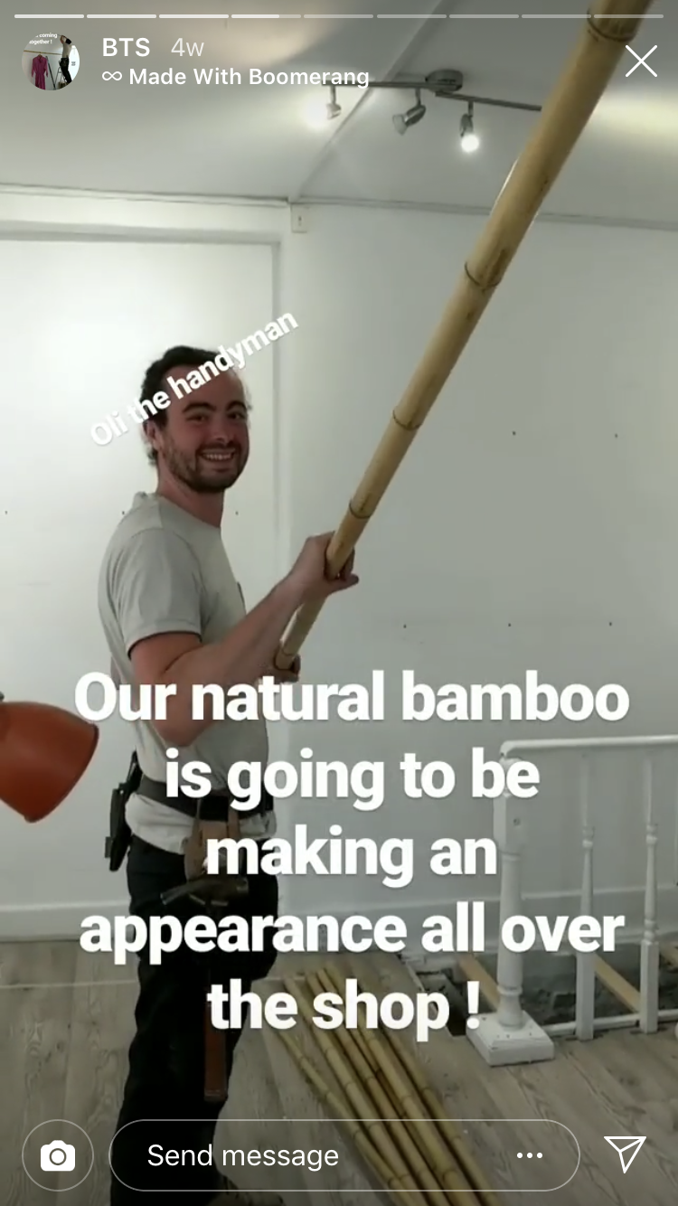https://www.instagram.com/stories/highlights/18009804145173306/

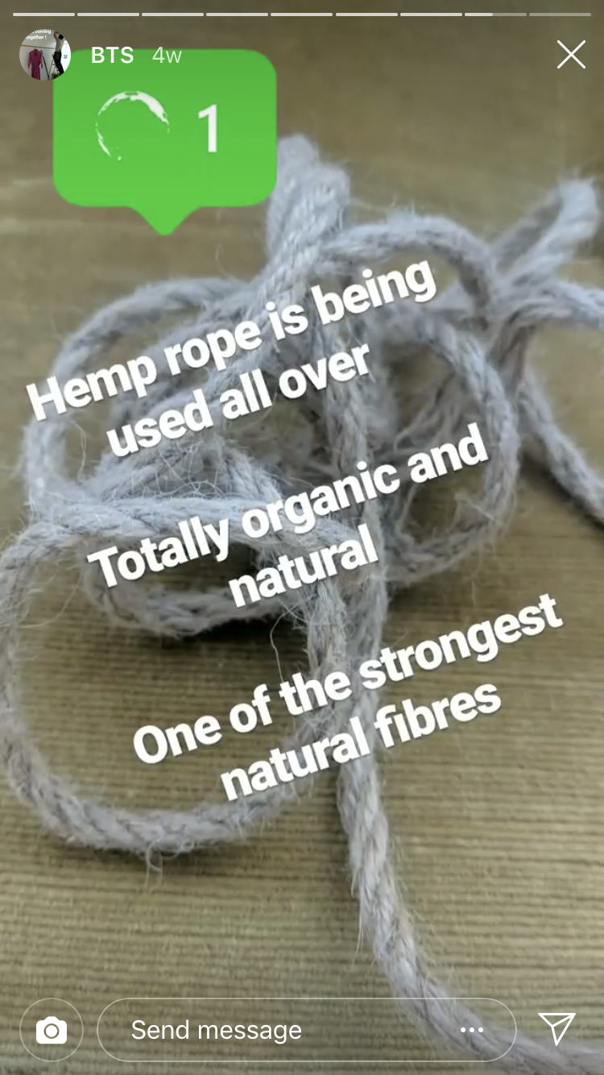https://www.instagram.com/stories/highlights/18009804145173306/

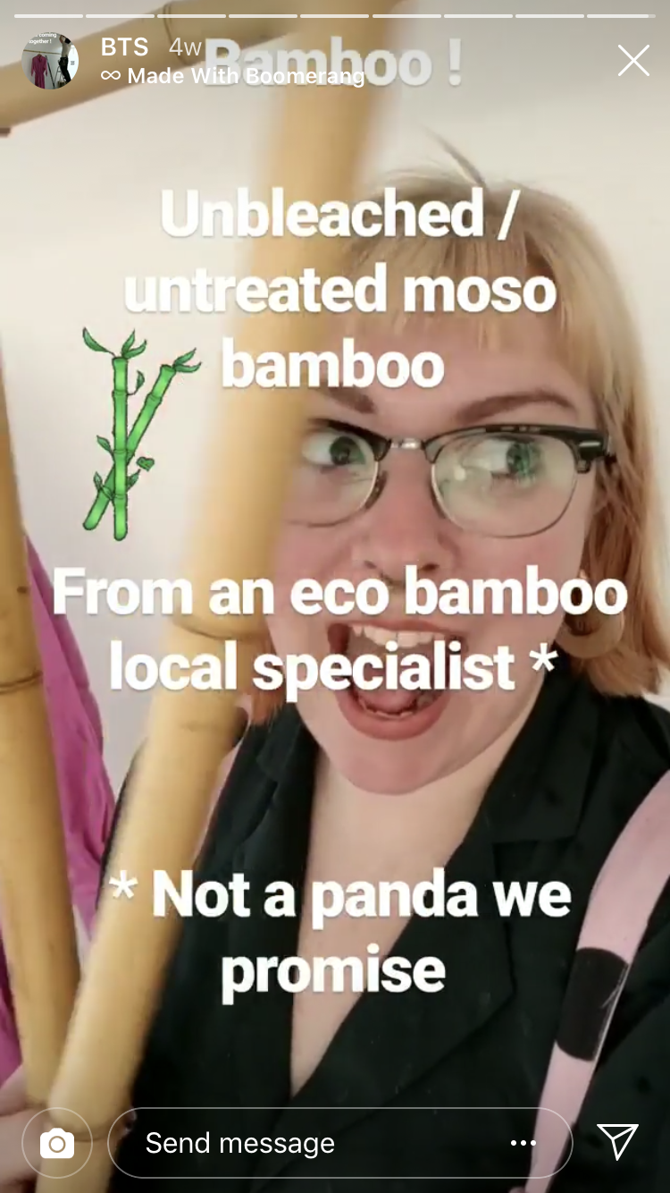https://www.instagram.com/stories/highlights/18009804145173306/

 https://lucyandyak.com/blogs/news/we-are-opening-a-store

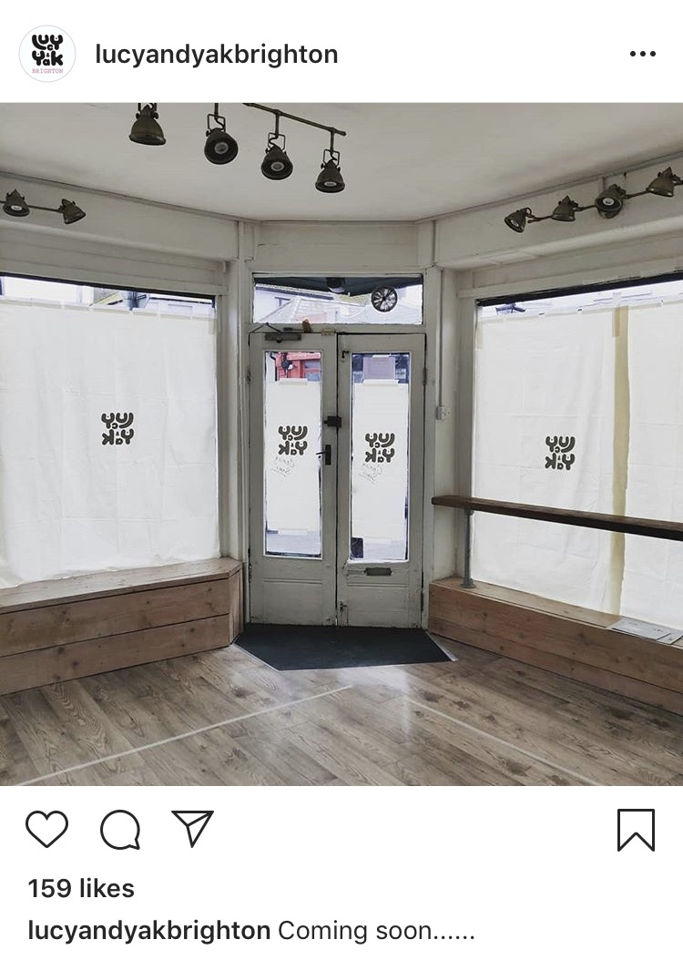 https://www.instagram.com/lucyandyakbrighton/

lucyandyak.com, 2019, Lucy, We are opening a store, (online), Available at: https://lucyandyak.com/blogs/news/we-are-opening-a-store, Accessed 10 May 2019

